REPORT
GENERAL SITUATION OF DROUGHT AND SALTWATER INTRUSION
IN THE SOUTHERN REGION 2019 - 2020
(Updated to 2 March 2020)

- 2019 – 2020 DROUGHT AND SALTWATER INTRUSION SITUATION
- 2019 - 2020 saltwater intrusion situtation
The rainy season in 2019 in the Mekong basin appears late, the duration of the rainy season is short, the total annual flow is only average - low. The flow to the Delta from the beginning of the dry season has rapidly decreased, and is now at a very low level compared to the yearly average from 1980 to present.
Two key upstream factors that dominate water resources, saltwater intrusion in the 2019-2020 dry season in the Mekong Delta (MD) are reserves in the Tonle Sap and the flow to Kratie (starting part of Mekong Delta). The flow of the Mekong Delta is seriously low compared to the yearly average, even lower than 2015 - 2016 (the year when the record saline intrusion occurred). This is the main cause to the early onset, deeper and prolonger saltwater intrusion during the 2019-2020 dry season.
Saltwater intrusion already very high since December 2020 (during 12 – 15 December 2019); the salinity limit of 4 g/liter in estuaries of Mekong river can approach as deep as 57km inland (in Ham Luong River) and deeper than the yearly average for 24km and than the salinity limit in 2015 for 17km. In January, the salinity limit of 4 g/liter increased during 6-13 January 2020 which is measured in the basins of 2 Vam Co rivers (Vàm cỏ Đông, Vàm cỏ Tây), i.e. intruding as far as 82-85 km inland, 18-20km deeper than in 2016; the saltwater intrusion depth in Mekong estuary is 45-66km; 6-17 km deeper than in 2016; 48km deep in land in the coast of West Sea and 6 km deeper than in 2016. From 8 – 16 February 2020, saltwater intrusion is in its high time together with the high tide with the salinity limit of 4 g/liter at 2 Vam Co rivers (Vàm co Đông, Vàm co Tây), i.e. intruding as far as 82-85 km inland, 18-20km deeper than in 2016; the saltwater intrusion depth in Mekong estuary is 45-66km; 6-17 km deeper than in 2016; 48km deep in land in the coast of West Sea and 6 km deeper than in 2016.
- Tonle Sap regime
The branch water level in Tonle Sap lake at Prek Kdam on February 27 is 1.29m high; Current water flows in a correlation with the water level of the Mekong River and the lake level. As of February 27, there is about 1.49 billion m3 remained, and the Tonle Lake basin contributes a significant amount of daily regulation to the downstream.
- Mekong Delta water regime
The flow on the Mekong River to the Mekong Delta in March is 5 - 20% inadequate compared to the yearly average and in 2016 average, the water level in Tonle Sap is low, with low possibility of replenishing additional water for the Mekong Delta.
Saltwater intrusion in the Mekong Delta is deeper, more severe than the average for many years. In some times, saltwater intrusion here may be equal or higher than the same period in 2016 (during high tide combined with strong winds). The time of saltwater intrusion on the Mekong River continues to increase in March 2020 (from March 6 to March 15); saltwater intrusion in Vam Co and Cai Lon rivers remained high in March and April 2020, after that, saltwater intrusion will gradually decrease.
In extreme cases, a long period of lack of rain combined with the use and exploitation of water resources in the basin (increased water use on tributaries and water storage in Chinese dams), will make the situation worse. Drought, water shortage, saltwater intrusion become more severe than the dry season 2015-2016.
- Current situation of saltwater intrusion till February 29, 2020
During the week, there is no rain in the Southern region. The temperature rises high in the noon and afternoon, many localities in the Southeast have hot weather with temperatures above 35°C. The water level in the Mekong mainstream changes slowly and is lower than the same period in 2016 from 0.1 - 0.6m. The water level on the Tien and Hau rivers is falling with the tide, The highest water level of the week in Tan Chau was 1.23m (February 26), in Chau Doc was 1.39m (February 26) equivalent to the same period in 2016. Saltwater intrusion in the Mekong Delta reaches its highest level on the first day of the week, then slowly decrease, the highest salinity level at the downstream stations of Tien river, Hau river, Vam Co rivers and the Ca Mau peninsula was lower than last week (February 11 - 20), Some areas in Ben Tre, Tien Giang and Ca Mau have higher salinity level.
- Vam Co Rivers (East Vam Co, West Vam Co): Saltwater intrusion extent is 87 - 99km, which is 4 - 25 km deeper over the same period in 2016;
- - Mekong estuary: Saltwater intrusion extents: Cua Tieu, Cua Dai rivers: 56 km, 13 - 15 km deeper over the same period in 2016 ; Ham Luông river: 78 km, 16 km deeper over the same period in 2016; Co Chien river: 51 km, 4 km deeper over the same period in 2016; Hau river: 49 km, 12 km deeper over the same period in 2016;
- Cai Lon river: Saltwater intrusion extent is 52 km, 9 km deeper over the same period in 2016.
Table 1: Saltwater intrusion of the river mouths till 29 February 2020
Area/River mouth/Station | Saltwater intrusion Depth  2019 – 2020 (Km) |  | Compared to the same period in 2016 (+/-Km)
Area/River mouth/Station | 21-21 February | Compared to last week | Compared to the same period in 2016 (+/-Km)
Vam Co River 2 branches area
Vam Co Dong (east) | 87 | + 8 | + 4
Vam Co Tay (west): | 99 | + 11 | + 25
Mekong River mouth area
Cua Tieu River | 56 | + 7 | + 15
Cua Dai River | 56 | + 7 | + 13
Ham Luong River | 78 | + 3 | + 16
Co Chien River | 51 | + 8 | + 4
Hau River | 49 | + 6 | + 12
West Coastal area on Cai Lon River
Cai Lon river | 52 | 0 | + 9
- Saltwater intrusion in the Mekong River mouth
Table 2: The highest salinity (g/l) till 29 February 2020 (According to Hydro-meteorological Station of Southern region)
TT | Station | River | Province | Distance to the river mouth (km) | Highest salinity (g/l) | Compared to the same period in 2016 (g/l) | Forecast S max 1-10 March
1 | Cau Noi | Vam Co | Long An | 20 | 18,4 | < 1,3 | 22
2 | Ben Luc | Vam Co Dong | Long An | 75 | 7,9 | < 1,8 | 11,6
3 | Tan An | Vam Co Tay | Long An | 80 | 8,1 | Xấp xỉ | 8,9
4 | Hoa Bin | Cua Tieu | Tien Giang | 30 | 9,6 | < 4,0 | 12,8
5 | An Dinh | Tien | Tien Giang | 48 | 5,9 | > 1,9 | 6,5
6 | My Tho | Tien | Tien Giang | 55 | 5,7 | > 3,1 | 5,9
7 | An Thuan | Ham Luong | Ben Tre | 10 | 28,8 | > 0,4 | 29,8
8 | Son Doc | Ham Luong | Ben Tre | 20 | 25,5 | < 1,9 | 27,1
9 | Tra Vinh | Co Chien | Tra Vinh | 35 | 7,8 | < 6,8 | 13,2
10 | Cau Quan | Hau | Tra Vinh | 32 | 9,2 | < 2,3 | 14,7
11 | Dai Ngai | Hau | Soc Trang | 30 | 8,9 | < 4,8 | 14,4
12 | Tran De | Hau | Soc Trang | 10 | 23,7 | < 3,6 | 26,2
13 | Ca Mau | Ganh Hao | Ca Mau | 52 | 29,4 | > 0,5 | 29,8
14 | Go Quao | Cai Lon | Kien Giang | 35 | 5,8 | < 5,2 | 10,7
15 | Xeo Ro | Cai Lon | Kien Giang | 7 | 12,6 | < 9,3 | 22,6
16 | An Ninh | Cai Be | Kien Giang | 8 | 7,2 | < 11,8 | 20,2
17 | Phuoc Long | K. Phung Hiep | Bac Lieu | Inland | 25,4 | > 8,1 | 25,6
- Salinity forecast from March 1 - March 10, 2020 (According to Hydro-meteorological Station of Southern region)
Regional weather in the coming period is less rainy, sunny days. Particularly the provinces in the Southeast continue to have hot weather in many places, the highest temperature in these provinces mainly from 33 - 36°C, in the Southwest region from 31 - 34°C. Afternoon humidity drops quite low, mainly in the range of 45 - 58%.
The upstream water level of the Mekong River changes slowly and is lower than the same period in 2016 by 0.1 - 0.5m. The water level on Tien and Hau rivers fluctuates according to the tide, the highest water level of the week in Tan Chau is 1.35m; at Chau Doc is 1.45m, equivalent to the same period in 2016.
Tendency of saltwater intrusion from 01 – 10 March 2020: saltwater intrusion on the Southern rivers will decreased gradually until March 5, the highest salinity at stations was approximately and lower than last week. From March 6 to 10, saltwater intrusion tends to increase, salinity will increase on March 10. From March 11 to 15, saltwater intrusion continued to increase and reached the highest level from March 11 to 13, then slowly decrease; the highest salinity level in this phase was equal to and higher than the one in February 10 - 13 and the same period in 2016.
- There are possibilities of salinity depth of 1g/l in this period as follows:
+ Vam Co Dong River, Vam Co Tay River: Saltwater intrusion extent is 110 - 130km;
+ Cua Tieu, Cua Dai and Ham Luong rivers: Saltwater intrusion extent is 65 - 95km;
+ Co Chien River: Saltwater intrusion extent is 60 - 65km;
+ Hau River: Saltwater intrusion extent is 60 - 67km;
+ Cai Lon River: Saltwater intrusion extent is 55 - 65km;
- There are possibilities of salinity depth of 4g/l in this period as follows:
+ Vam Co Dong River, Vam Co Tay River: Saltwater intrusion extent is 87 - 110km;
+ Cua Tieu, Cua Dai and Ham Luong rivers: Saltwater intrusion extent is 55 - 60km;
+ Sông Hàm Luông: Phạm vi xâm nhập mặn 68 - 78km;
+ Co Chien River: Saltwater intrusion extent is 55 - 68km;
+ Hau River: Saltwater intrusion extent is 60 - 67km;
+ Cai Lon River: Saltwater intrusion extent is 50 - 58km.
The level of disaster risk from saltwater intrusion in the Mekong Delta is at level 2.
In the period from March 1 to 5, due to the influence of low tide, localities in the Mekong Delta need to take advantage of fresh water storage. During the peak salinity from March 06 to 15, 2020, localities restricts irrigation (minimum irrigation) to minimize production losses. For fruit-growing areas of high economic value with poor salinity tolerance, salinity concentration must be checked before watering.
Saltwater intrusion trend in the upcoming months of 2020:
The flow on the Mekong River to the Mekong Delta in March is 5 to 20% inadequate compared to the yearly average and in 2016 average, the water level in Tonle Sap is low, with low possibility of replenishing additional water for the Mekong Delta. The saltwater intrusion situation in the Mekong Delta continued to be fierce in March 2020, especially in the period from March 11 to 15, saltwater intrusion may be equal or higher than the peak period in mid February and the same period in March 2016, greatly affecting production and daily life, then tends to decrease gradually until the end of March; saltwater intrusion of Vam Co and Cai Lon rivers remained high until the end of April 2020, after that, saltwater intrusion is likely to decrease.
In extreme cases, a long period of lack of rain combined with the use and exploitation of water resources in the basin, will make the situation worse. 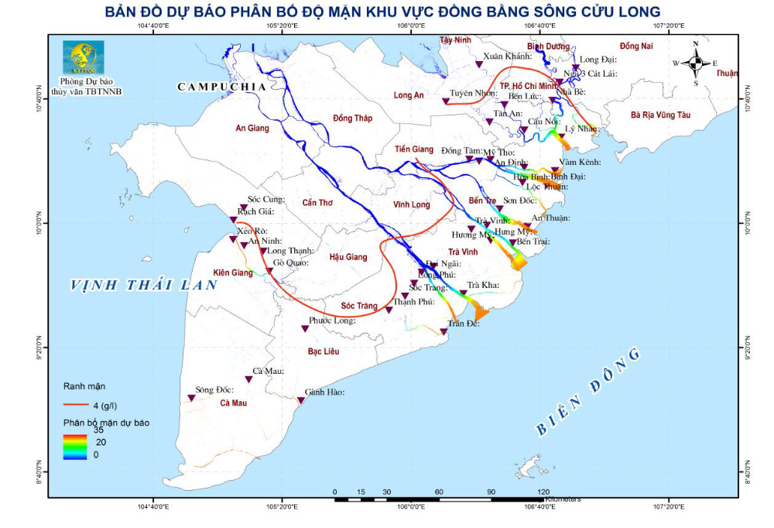
Forecast map of saltwater intrusion distribution in the Mekong Delta

- General assessment of the current status and potential of water sources (According to the Southern Institute of Water Resources Research till February 29, 2020)
On February 20, China announced the release of water on the Mekong River to help its neighbors cope with drought, but it has now been seven days since the declaration, which is more than the time needed for water to flow from Canh Hong to Chiang Saen, but there has been no change. Actually, the operation of Chinese hydroelectric dams this year has been half a month later than the same period in 2018-2019. Therefore, the upcoming discharge (if any) is only according to the plan of 2020. Currently Chinese hydropower discharge is still low.
Therefore, it is forecast that saltwater intrusion will deeply penetrate the delta in March, and the March saltwater intrusion peak will appear in weeks of March 8 to 16 and March 18 to 26. Salinity will be lower in next week. With the current water source characteristics and as forecast, the water forecast for the three Mekong Delta regions is as follows:
- Upper Mekong Delta: Including the land of An Giang, Dong Thap, upstream Long An, Kien Giang and Can Tho city, low water head, difficult to pump in to locations far from the canal.
- Middle Mekong Delta: Including the land of Can Tho city, Tien Giang, Long An, Kien Giang, Hau Giang, Dong Thap and Vinh Long provinces and saltwater intrusion controlled areas in Bac Lieu, Soc Trang, Tra Vinh, Ben Tre: saltwater intrusion decreased in the week compared to the previous week. Localities should take the initiative in measures to store water, decant at low tide in areas 45 - 55 km from the sea, to prevent high saltwater intrusion from March 7 to 15.
- Coastal region of Mekong Delta: Including coastal provinces in the Mekong Delta (Long An, Ben Tre, Tra Vinh, Soc Trang, Bac Lieu, Ca Mau and Kien Giang): Responding to historical saltwater situation, actively taking measures to respond to drought/ saltwater situation and supplying water for living, actively storing water before salinity increases.
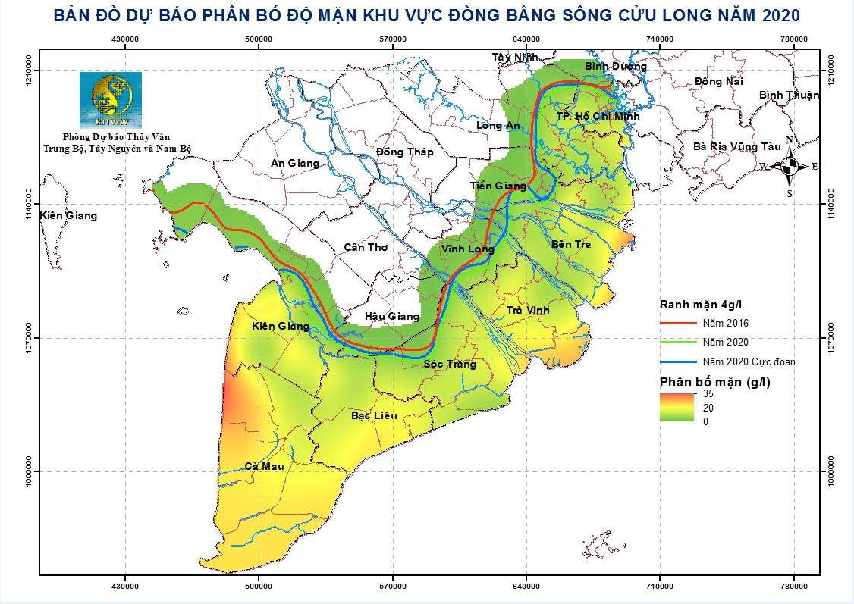
Forecast map of saltwater intrusion distribution in the Mekong Delta 2020

- EFFECTS OF DROUGHT AND SALTWATER INTRUSION TO PRODUCTION AND POPULATION (as of February 29, 2020)
Bảng 3: Kế hoạch sản xuất lúa năm 2019 - 2020 các tỉnh ĐBSCL
No |  | PROVINCE | RICE AREA (ha)
No |  | PROVINCE | Winter-Spring 2019 - 2020 | Summer-Autumn 2020
1 |  | Long An | 232,000 |  | 221,612
2 |  | Tien Giang | 64,500 |  | 93,709
3 |  | Ben Tre | 0 |  | 13,655
4 |  | Tra Vinh |  |  | 74,993
4 |  | Tra Vinh | 68,500 |  | 74,993
5 |  | Vinh Long | 55,000 |  | 53,171
6 |  | Đong Thap | 205,000 |  | 196,615
7 |  | An Giang | 233,500 |  | 230,465
 |  | Kien Giang |  |  | 283,302
8 |  | Kien Giang | 290,000 |  | 283,302
9 |  | Can Thơ | 81,000 |  | 79,612
10 |  | Hau Giang | 78,000 |  | 78,082
11 |  | Soc Trăng |  |  | 142,501
11 |  | Soc Trăng | 198,000 |  | 142,501
12 |  | Bac Lieu | 48,000 |  | 58,673
13 |  | Ca Mau | 36,500 |  | 36,000
 | Total |  | 1,590,000 | 1,590,000
- Risk of production impact: About 332,000 ha of winter-spring rice (about 94,000 ha in 09 provinces: Long An, Tien Giang, Ben Tre, Tra Vinh, Kien Giang, Hau Giang, Soc Trang, Bac Lieu and Ca Mau); 136,000 ha of fruit trees will be affected (about 80,600 ha in some districts of 08 provinces: Long An, Tien Giang, Ben Tre, Tra Vinh, Vinh Long, Soc Trang, Hau Giang, Kien Giang).
- Risk of domestic water shortage: In the next period of the 2020 dry season, about 158,900 households will be short of running water.
- DAMAGE SITUATION
- Ca Mau province
+ Damage to production: The damaged rice area is 16,554.8 ha (of which 30 to70% is 3,756.96 ha; Over 70% is 12,797.85 ha) in Thoi Binh, U Minh and Tran Van districts. Time, The Water. Dong Xuan rice area was damaged: 10,644 ha (30 to 70%: 10,000 ha,> 70%: 644 ha). Damaged vegetable area> 70%: 3.6 ha (Tran Van Thoi district).
+ Shortages of water for domestic use: The total number of households with water shortages is 3,568 (it is expected that by the end of the dry season, there will be 13,500 more water shortage households).
+ Situation of subsidence along the canal: The prolonged drought causes dried out canals with no oppression, causing landslides in rural roads with 887 points (21,167m). specifically: Khanh Binh Tay commune: 09 landslides with a length of 221m; Khanh Binh Dong commune: 13 landslide routes with a length of 2,440m; Khanh Hai commune: 14 lines collapsed with a length of 1,501m; Tran Hoi commune: 07 routes with a length of 306m; Khanh Hung commune: 08 routes with a length of 623m; Khanh Binh commune: 11 routes with a length of 830m; Khanh Loc commune: 08 routes with a length of 273m and Tran Van Thoi Town: 05 routes with a length of 164m;
+ The incident of bottom erosion of Thuật Nam Sluice in Trần Văn Thời district: on 22.00 of 14 January 2020, an erosion of the sluice bottom caused the saltwater to intrude into the water desalination area and on 15 January 2020, the sluice gate was buried. Current salinity (31 January 2020) outside the sluice is 25% 0, salinity in the sluice after treating and pumping out water, has returned to normal and no longer affects production and daily life.;
- Ben Tre Province: Damage of 104.7 hectares of Autumn-Winter rice (30 to 70%); 5,000 ha of Winter-Spring rice grows and develops slowly (high probability of losing the crop). All people in the province are affected due to salted water.
- Tra Vinh Province: Damage of 624 hectares of Dong Xuan rice (30 to 70%: 461 ha, >70%: 163 ha); The total number of households lacking clean water is 8,662 households (Cang Long district, Chau Thanh).
- Vinh Long Province: The total number of households affected by salted water sources is 66,200 households (districts of Vung Liem, Tra On, Mang Thit and Tam Binh).
- Kien Giang Province: Completely damages 172ha of winter rice (An Minh district), 1,503ha of Winter-spring rice (30 to 70%).
- Soc Trang Province: Damage of 1,000 ha of Winter-Spring rice (30 - 70%: 773 ha,> 70%: 227 ha).
Provinces of Long An, Tien Giang, Bac Lieu, Hau Giang, Can Tho, Dong Thap and An Giang have not yet suffered from saline drought and saltwater intrusion.

- Directions on drought and saltwater intrusion responses
- At central level
- On 22 January 2020, the Prime Minister issued Directive No. 04/CT-TTg on the implementation of urgent measures to prevent and control drought, water shortage and saltwater intrusion.
- On 3 January 2020, the Conference on drought and saltwater intrusion Prevention and Control in the Mekong Delta Region in 2019-2020 in Ben Tre, chaired by Deputy Prime Minister Trinh Dinh Dung. Minister of Agriculture and Rural Development and the Government Office issued the Notice of Conclusion No. 16/TB-VPCP dated January 14, 2020.
- September 27, 2019 The Government had a meeting with Mekong Delta provinces on the prevention and control of river and coastal bank erosion for Winter-Spring crop 2019 - 2020
- The Ministry of Agriculture and Rural Development issued Directive 8008/CT-BNN-TCTL dated 25 October 2019 to strengthen the implementation of drought, water shortage, saltwater intrusion prevention and control measures to serve agricultural production and livelihood during dry season 2019 - 2020.
- The Ministry of Agriculture and Rural Development issues Official Letter 6708/BNN-TCTL dated September 12, 2019, on preparing for the implementation of prevention and combat against saline water intrusion in the dry season 2019-2020.
- Ministry of Agriculture and Rural Development organized a conference to agree on water storage and production plans to ensure the productivity of the Winter-Spring crop of 2019-2020 and ensure domestic water supply;
- Southern Sub-Department of Natural Disaster Management regularly directs and urges localities in the region to closely monitor drought, saltwater intrusion developments and related damages and update and send reports to the Sub-Department and related agencies.
2. Localities
- Localities have closely followed directives of higher levels and issued specific steering guidance to cope with drought and saltwater intrusion as directed by the Central Steering Committee for Natural Disaster Prevention and Control and relevant ministries and sectors and actively implemented measures to prevent and control drought and saltwater intrusion;
- Regularly communicate and inform people on the mass media about drought and saltwater intrusion to take initiative in coping measures;
- Currently, 13/13 provinces and cities in the Mekong Delta region have issued plans to prevent and combat drought, water shortage and saltwater intrusion in the dry season 2019-2020 (Ca Mau, Soc Trang, Hau Giang, Tien Giang, Ben Tre. , An Giang, Dong Thap, Vinh Long, Tra Vinh, Long An, Bac Lieu and Can Tho); Particularly, Tien Giang and Ben Tre issued a Decision to declare the state of emergency due to drought and saltwater intrusion in the province.
Implementation:
2.1. Vinh Long: direct most downstream districts such as Vung Liem, Tra On, Mang Thit and Tam Binh to open sluices to intake freshwater during low tide; Regularly sending SMS to 292 subscribers as leaderships at 3 levels from commune to province; Continue to coordinate the operation of Vung Liem sluice and other irrigation works to proactively close and open salinity control sluices to get, store and supply freshwater for production and domestic uses. Issuing Official Letter No. 08/PCTT to proactively implement measures to prevent and control drought and saltwater intrusion which is now quite serious and is causing water shortage during high tide in the full moon time of January (February 8 - 16); submit for approval of the PPC the Prevention and control Plan for “possibly very serious” Drought and saltwater intrusion during remaining months of dry season 2019 - 2020. Prepare Survey plan for Drought, Saltwater intrusion and pests in districts, towns and cities. Communes in Vung Liem district have built 3 small irrigation works with a total length of 1,854 m and a total capacity of 2,115m³ to store water and prevent drought and saltwater intrusion.
2.2. Tien Giang: Close the Vam Giong sluice on 22 November 2019 (30 days earlier than the yearly average time); get freshwater through Xuan Hoa sluice in limited regime during 7 – 17 December 2019, during late afternoons of January 6 - February 3, 2020 and in normal regime during 18 December 2019 – 6 January 2020; operate 4 pumping stations (Binh Phan, Son Qui sluice, head of Tran Van Dong canal and head of Champeaux canal) to prevent drought from 9 January 2020 to date; close all sluices in the Phu Thanh - Phu Dong project area to prevent saltwater intrusion; Go Cat sluice is closed on 8 January 2020, and freshwater water exploitation through Bao Dinh sluice is not stable since 9 January 2020. Buying 10 pumping boats (capacity of 1,800m³/h/boat, engine type: HL-1800-6.5) for Cong Xuan pumping station; install 12 pumping boats (capacity of 2,200m³/h/boat, engine type HT-1,100-1.5) at Son Qui sluice. Collaborate with Long An DARD to build 6 dams (section from Bac Dong sluice to Ben Ke canal) including: Ba Hai Dam; Ong Nhuong Dam; Ba Dinh Dam; Thu Con Dam; La Khoa Dam, Ben Ke Dam and close sluice gates on National Highway 62. Currently, the province is embank steel sheet dams to prevent saltwater intrusion at the head of Nguyen Tan Thanh canal (starting on 08 February). As of 10 February 2020, 267 areas have been pumped and stored with water using 775 pumps (135,147 pumping hours), mainly in Cho Gao, Go Cong Tay, Go Cong Dong districts and Go Cong Town. Many legal documents have been issued to guide the drought and saltwater intrusion prevention and control and protection of crops and rural domestic water supply in Eastern districts in the dry season of 2019-2020 in Tien Giang province.
Organized a meeting to discuss drought and saltwater intrusion prevention and control solutions in Tien Giang province on 11 December 2019. Organized an inspection mission to fix urgent problems of critial works at the request of localities.
Surveyed and built 8 drilled wells to supply water to Dong Tam and Binh Duc Water Plants and agreed on the proposed locations of 8 steel sheet dams: Canal 1, Canal 2, Canal 3 (on the east bank of Nguyen Tan Thanh Canal); Cau Dap, Cau Ban, Cau Van and Cau Dua canals (on the west bank of Nguyen Tan Thanh Canal) and Ben Ke Steel Dam on National Highway 62 (Long An province).
Localities have developed specific drought and saltwater intrusion prevention plans and implemented solutions in accordance scenarios developed and happened in 2016. Installed 50 public water taps to ensure additional water supply for local people.
2.3. Ben Tre: Regularly transporting fresh water to affected areas; On 3 February 2020 Kenh Lap fresh water reservoir in Ba Tri district (capacity of 800,000 m³) was affected by saltwater intrusion (concentration: 1.5%₀) and cannot be used for drinking.
Equipped 12/35 provincial water supply stations with RO salinity filters to create enough fresh water supply for people; the Navy Command 2 used their naval ship to transport 250m³ of fresh water to supply Ba Tri district ( 03 communes: Tan Thuy, An Thuy and An Hoa Tay).
2.4. Long An: Send notices to all provincial departments and agencies on drought and saltwater intrusion situation and water quality together with directed response measures.
2.5. Kien Giang: Direct the strict implementation of cropping calendar; operate 55 sluices along Cai Be river and 17 sluices in U Minh Thuong area to prevent salinity and retain freshwater; reinforced and built to 70 salinity control dams to protect Winter-spring and Summer-autumn rice areas; it is expected to build another 83 dams more when salinity entered further; build salinity control dam using Larsen sheet piles at Nhanh canal, Rach Gia city to keep freshwater; Operate Ba Hon sluice to ensure fresh water supply for Kien Luong district; Operate Ha Giang sluice to ensure sufficient water supply for Ha Tien water plant (1 million m³ freshwater reservoir in Giang Thanh district). The province has allocated funds to expand the pipeline network and raise the water supply plant capacity to ensure water supply for 9,000 households; the remaining households lacking water will be supplied by water tank trucks. Strengthen the saltwater intrusion survey along main canals, timely informing local departments and agencies and people about the situation so that they can proactively arrange their production and domestic activities. Affected localities have built seasonal dams to prevent saltwater intrusion and protect Winter-spring rice and prevent drought for Summer-Autumn crop 2020; built 124/180 dams (02 dams made of Larsen steel piles in Kien Luong and Rach Gia); built 120 earth dams (An Minh 10, An Bien 23, Giang Thanh 01, Kien Luong 05, Go Quao 76, Chau Thanh 07). Up to 31 January 2020, Go Quao district built 76/76 dams; Giong Rieng district started the dam building of 56 dams as early as 3 February 2020.
2.6. Ca Mau: Carry out propaganda and raising awareness activities to persuade people to use water economically; transported water to supply to areas affected by water shortage for domestic uses. Place wires and install warning signs along subsidence roads to alert people. Drill concentrated wells and support people with water storage tools for scattered residential areas (4,188 households); intended to build a new concentrated water supply work to serve 4,090 households. Organized inspection and monitoring of salinity and allocated regular forces to check critical points along dykes, sluice and dams (along Ong Doc, Cai Tau, Bien Nhi rivers and West sea dykes, Sub-regions II and III in the North Cà Mau).
Coordinated with schools, departments and institutes to develop and design solutions to handle seepage through sluice bottom deck (using Jet-Grouting technology or inorganic cement mixture of Polime and Silicate) for Tac Thu - Song Doc canal and West Sea dike.
2.7. Bac Lieu: Regulate water into Gia Rai town through small sluices to supply salt water to Gia Rai town in Phuoc Long district for aquaculture production before Tet holiday. Opened Gia Rai sluice (3 gates) and Ho Phong sluice (3 gates) gates during 24 January 2020 to 28 January 2020 to push the 2.5%₀ saltwater at Ninh Quoi intersection back to Phuoc Long to limit saltwater intrusion through Ninh Quoi intersection. At the same time, Sau Tau and Tu Tao sluice gates are opened; Nga Nam Town (Soc Trang) also opened Nam Kieu and Cong Da sluices to supply fresh water to Bac Lieu. On January 28, 2020, Sau Tau, Tu Tao and Nam Kieu sluices are closed due to the presence of 2,5%₀ saltwater. From 27 January 2020 DARD cooperates with Irrigation project PMU 10 to temporarily operate Au Quoi ship lock - sluice gate so far to prevent saltwater intrusion through Nga Nam - Soc Trang town area.
2.8. Soc Trang Province: 115 km of water supply pipeline network has been expanded to serve 4,000 households; another 604 km of pipelines in 2020 will be continued to be built to ensure water supply for 22,400 households.

- RECOMMENDATIONS
Given the updated flow developments to the delta so far, a drought and saltwater intrusion situation even more serious than the historic 2016 drought occurred. At present, hydropowers in China are discharging very low flow and the situation is likely to last until early March. As a result, it is visible that drought and saltwater intrusion may continue during the 1st half of March. Therefore, localities are advised to store water and operate sluices properly, getting freshwater whenever possible, limiting drainage and controlling saltwater intrusion in irrigation systems, storing water even before incremental upstream effects.
Strengthen the monitoring of saltwater intrusion, updating forecasting bulletins on regular basis to adapt plans to water resource developments.
VI. SALTWATER INTRUSION CONTROL WORKS IN MEKONG DELTA USING STATE BUDGET THROUGH MARD
- Total capacity of operated saltwater intrusion control works for dry season 2019-2020
Up to now, 5 projects have bên put into use to control salinity for the dry season 2019-2020 ((1) Ninh Quoi ship lock project; (2) 3 sluices of Vung Liem, Bong Bot and Tan Dinh belonging to the Water resources Control and Adaptation to Climate Change in Nam Mang Thit area Sub-Project - ICRSL Project); (3) Irrigation system project of Xuan Hoa pumping station; (4) May Phop Canal Dredging Project; (5) 18 sluices in Northern Ben Tre Irrigation System Project Phase 1; controlling an area of ​​83,000 ha; with salinity control impacts for 300,000 ha of culvert land
2. Projects decided by MARD for investments during 2017-2020.
2.1. Ninh Quoi ship lock project
- Scale of work: (1) Ninh Quoi ship lock has 02 open sluices at both ends with a flow width of B = 31.5m, elevation of sluice threshold (-3.60) m and a lock chamber of 150m long, bottom width: 31.5m, bottom elevation: -3.60 m; (2) Ninh Quoi sluice includes 01 chamber of B = 15m wide and sluice threshold elevation of -3.00 m;
- The project commenced in November 2018 and shall be completed in April 2021 as per contract. Up to now, 98% of the contract volume has been completed, Hydraulic items have been completed, gates installed and hydraulic cylinders installed. Landscape of the sluice is being completed.
On 06/01/2020, the ship lock was temporarily transferred to Bac Lieu Irrigation Management Center for management and operation to control saltwater intrusion and keep freshwater for production.
The ship lock is scheduled to be completed and officially handovered to local management in early March 2020 which 13 months ahead of schedule;
- Currently, items under the project have been put into operation and investments proved efficiency: (1) the work items have proactively regulated saltwater intrusion and kept freshwater for rice and upland crop areas in Bac Lieu, Soc Trang province (26,500ha) and an affected area of 104,000 ha; (2) Contributed water resources regulation for aquaculture production in the shifted farming area in the North of National Highway 1A of Bac Lieu province (8,500 ha); (3) Proactively respond to climate change and sea level rise;
2.2. Sub-project: Water resource control and adaptation to climate change in South Mang Thit, ICRSL project
- Scale of work: Building 03 sluices: Vung Liem (03 chambers and 25m wide each), Bong Bot (03 chambers and 20m wide each), Tan Dinh (02 chambers and 20m wide each);
- The project was started in July 2018 and expected to be completed and handovered to local management in early March 2020, Bong Bot sluice and Tan Dinh sluice were put into operation on 8 January 2020; Vung Liem sluice was temporarily operated on 20 January 2020; the construction implementation time is 06 months. Up to now, all sluices have been put into operation to timely serve drought and saltwater intrusion during dry season 2019-2020;
- The project was put into operation early and timely; the project also proved investment efficiency as it helped: (1) Control salinity and high tide, creating clean water sources, draining waterlogging, reclaiming 28,459 ha of natural land in Vung Liem and Tra On districts of Vinh Long province and in Cau Ke district of Tra Vinh province (Vung Liem 11,375 ha; Tra On 5,614 ha and Cau Ke 11,470 ha) and serving an affected area of 67,000 ha; (2) Proactively get water, drain water, collect alluvium, acidify soil and wash alum in preparation for combined agricultural and aquaculture production towards diversification of domestic plants and animals.
2.3. Xuân Hòa sluice Pumping Station Irrigation System
- Scale of work: (1) Xuan Hoa sluice pumping station with a total capacity of 5m³/s, including 10 pump blocks located on a buoy; (2) Building 05 open sluices with a width of 3m ÷ 10m each; (3) Dredging channel 14 of 8.07km long and bottom width of 15m;
- Currently, except for 02 open sluices (Ba Hai Mang and Ong Nhuong) which are recently built in December 2019, all the main items of the project have been completed and handed over to localities for management during December 2019 – January 2020, about 8 months ahead of schedule to timely prevent and control drought and saltwater intrusion in the dry season 2019-2020.
- The project will be put into operation, exploitation and soon promote the its investment efficiency through (1) Direct saltwater intrusion control for 15,041 ha, supplying freshwater source to the Go Cong Desalination Project area for a total cultivated area of ​​39,181 ha (including 28,530 ha of rice; 10,551 ha of fruit trees and perennial crops) and about 7,300 ha out of 64,164 ha under the service of Bao Dinh Irrigation Project.
2.4. May Phop - Nga Hau Canal Dredging Project
- Scale of work: Dredging the canal, starting from Vung Liem river and then along the May Phop - Sung Don - May Tuc - Nga Hau canal and ending at Tra Ngoa canal. The total canal length is 24.54 km and canal bottom width is 10m - 18m and bottom height is (-3.0) m;
- Up to now, all work items in the project have been basically completed (up to 24.54km/24.54km of May Phop - Nga Hau canal has been dredged; all open and submerged sluices along the canal banks are dredged before 30 December 2019 to timely respond to drought and saltwater intrusion in the dry season 2019-2020.
- The project was put into operation ahead the schedule together with Cai Ca - May Tuc canal, Nga Chanh canal, Tra Ngoa canal and canals belonging to Hau river tributary (Bong Bot, Ram Soc, My Van) has helped (1) Supply additional fresh water to 30,000 ha of agricultural and aquaculture combined land in the east of Tra Ngoa canal and the east of Canal 3/2 (located in Cang Long, Cau Ke and Chau Thanh districts of Tra Vinh province and part of Vung Liem district in Vinh Long province); (2) Flooding, acidifying, washing alum, pushing salt for 160,680 ha of natural land in Tra Vinh province and 6,000 ha of rice cultivation land and 1,461 ha of fruit tree land of Vung Liem district, Vinh Long province.
2.5. Northern Ben Tre Irrigation System Project - Phase 1, Ben Tre Province
- Scale of work: (1) Dyke along Tien river from An Hoa sluice to No.6 length of L = 26 km, peak elevation (+3m), dyke surface of 6m wide; (2) Dyke along Ham Luong river from Son Hoa commune to Ong Boi road, length L = 5.76km, dike crest level (+3.00), dike width B = 6m; (3) construction of 39 open sluices with a width of B = 3m ÷ 20m; 38 box culverts with dimensions BxH = (1.5m x 3.2m) ÷ (3.0m x 3.7m); 07 centrifugal concrete sluices, diameter of Ø100cm ÷ Ø150cm.
- The project is under construction phase, currently 26km of Mekong river dike and sluices under dykes have been built; 32/39 open sluices (temporarily handed over to the local to manage 18 sluices) and 10/38 box sluices. Other items will be completed in the near future, by 31 December 2020. The completed works in the project contribute to saltwater intrusion prevention and freshwater retention for 80,000 ha of the North Ben Tre area bordering Mekong river (among 139,000 ha of the controlled area of ​​the project area).
2.6. South Ben Tre Irrigation system in
- Scale of work: Building 06 open sluices (width of B = 5m ÷ 20m, flow width: 05m – 20m) to replace 5 existing salinity control earth dams (Tang Du, Ca Rang Dong, Cai Ca, Nha Tho, Nam Lai) and head of Giong Luong canal;
- The project is in the construction phase and 40% of the workload has been completed and is scheduled to be completed before 31 December 2021.
2.7. Tra Su and Tha La sluices
- Scale of work: (1) Building Tha La sluice (flow width B = 66m; the sluice is divided into 03 chambers of 22m wide each; (2) Building Tra Su sluice (flow width of B = 88m; the sluice is divided into 04 chambers of 22m wide each);
- The Project has basically completed i.e. main items of the sluice (54% of the implementation time and over 70% of the workload). Currently, upstream, downstream items and valve towers are being built to make sure the project will be finished before flood season in 2021.
2.8. Investment in technical infrastructure of specialized culvert area for lemon trees in Hoa Binh Nam commune, Duc Hue district and Thanh Hoa and Thanh Loi communes in Ben Luc district:
- Scale of work (1) Outer ring dike: upgrading and repairing the dike along a total length of 87,070m; (2) paving with stone and upgrading canal banks for combined rural road along a length of 5,500m; (3) Building 138 sluices under dyke to ensure water supply, water drainage and stable water environment in the diked area; (4) Building 07 bridges on across the outer dike route; (5) Erecting 28,865m of 3-phase power lines along main axes of canal;
- The project is in the investment preparation stage;
2.9. Irrigation Systems in the sub-zone 2, 3 and 5 in Ca Mau
- Scale of work: (1) Sub-region II: Building 22 open sluice gates with flow width of B = 2 ÷ 15m; (2) Sub-region III: Building 06 pumping stations with 2 ÷ 4 pumps each station; capacity of each pump: Q = 5,500m³/h; the pumping stations are built where sluices are built; (3) Sub-region V: Building 05 open sluice gates with flow width of B = 4 ÷ 8m at the head of open canals; building dike along Cai Doi Vam river with a total length of 21,74km;
- The project is in the construction phase; as much as 40% of the workload has been completed; the project is expected to be completed before 31 December 2021.
2.10. Cai Lon - Cai Be irrigation system - Phase 1
- Scale of work: (1) Cai Lon sluice including 11 chambers of 40m and 01 ship lock chamber of 15m; flat steel valve gate is operated vertically using hydraulic cylinder; (2) Cai Be sluice consists of 2 chambers of 35m and 1 ship lock chamber of B = 15m; flat steel valve gate is operated vertically using hydraulic cylinder; (3) Dyke connecting Cai Lon sluice, Cai Be sluice and National Road 61 is 5,742 km long and 9m wide; vehicle road width is 7m and dyke edge is 2x1m wide;
- The new project was started in October 2019 and now is in the construction phase; 70% of the workload will be completed before December 31, 2020 and the rest of the project will be finished before November 2021;
2.11. Ben Tre Water Management Project (JICA3)
- Scale of work: Building 08 sluices and 01 pumping station: (1) 05 sluices in the North of Ben Tre: An Hoa (04 chambers of 30m each, 02 chambers of 12m each), Thu Cuu sluice (03 chambers of 30m each), Ben Tre (02 chambers of 35m, 02 chambers of 12m each), Tan Phu (20m), Ben Ro (20m); (2) 03 sluices in the South of Ben Tre: Cai Quao (03 chambers of 30m), Vam Nuoc Trong (03 chambers of 30m each, 01 compartment of 12m for ship lock), Vam Thom (02 compartments of 35m each, 01 chamber of 12m for ship lock; (3) 01 Tan Phu Electric Pumping Station with capacity of 20m³/s (equivalent to 72,000m³/h), including 8 pump units with a capacity of 12,400 m³/h (6 main pump units and 2 spare pump units);
- The new project was approved for investment capital in September 2019. The project is currently in the stage of technical design, construction drawings and site clearance. The construction of Tan Phu and Ben Ro sluices will be started is December 2020 and completed in December 2022; the construction of Thu Cuu and Cai Quao sluices will be commenced in May 2021; Vam Thom, Vam Nuoc Trong, Ben Tre and An Hoa sluices will be started in August 2021. The monitoring and supervision system will be started in January 2022 and completed in December 2024

